Hotflix

Online Movie Booking System

( DEVELOPER GUIDE )

# PROJECT GROUP MEMBERS

|  |  |
| --- | --- |
| STUDENT’S ID | STUDENT NAME |
| Student1555602 | **Abdul Haseeb Qazi** |
| Student1544631 | **Syed Yousuf Hussain** |
| Student1544538 | **Muhammad Awias Miskeen** |
| Student1521685 | **Muhammad Saad** |

**CURRICULUM BATCH**

**7062 2312F**

**FACULTY**

**“MS. DAANIA SHABIH”**

# USER PAGE

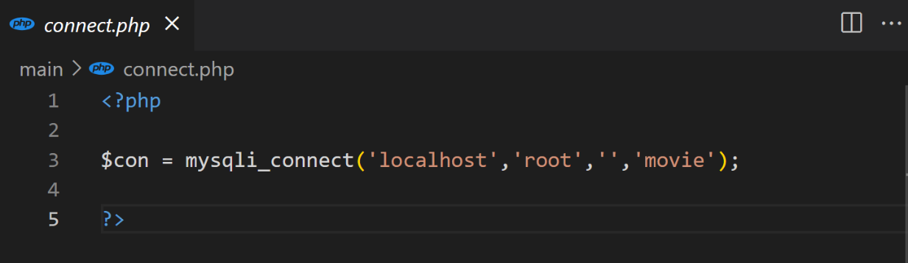**Database Connection:**

**User / Admin Signup page**

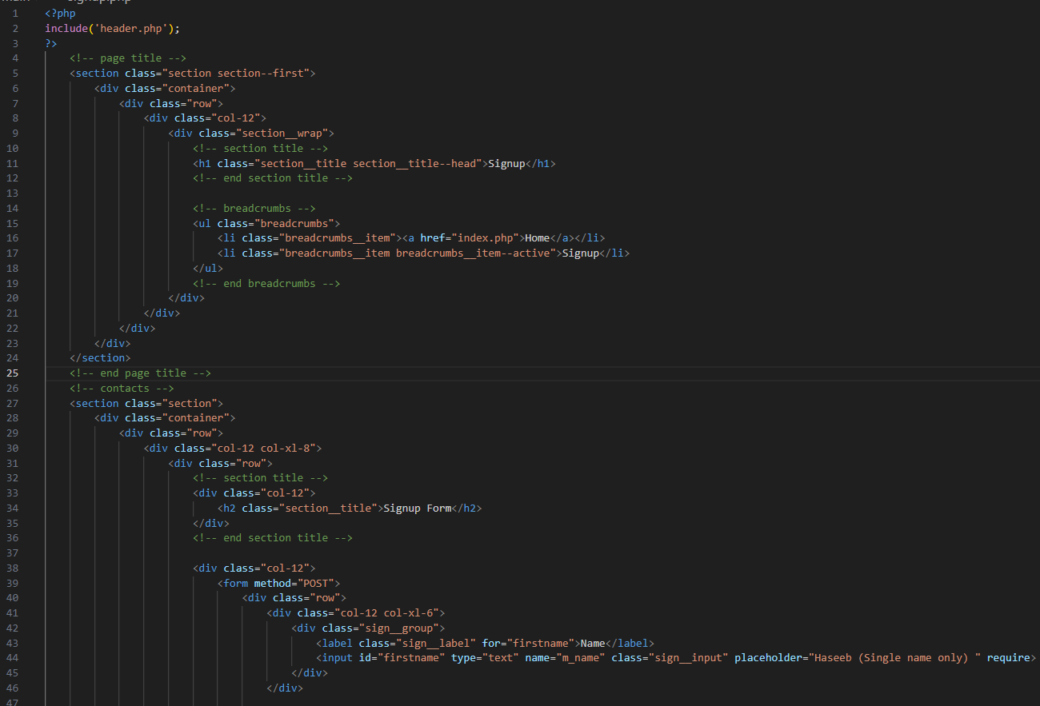

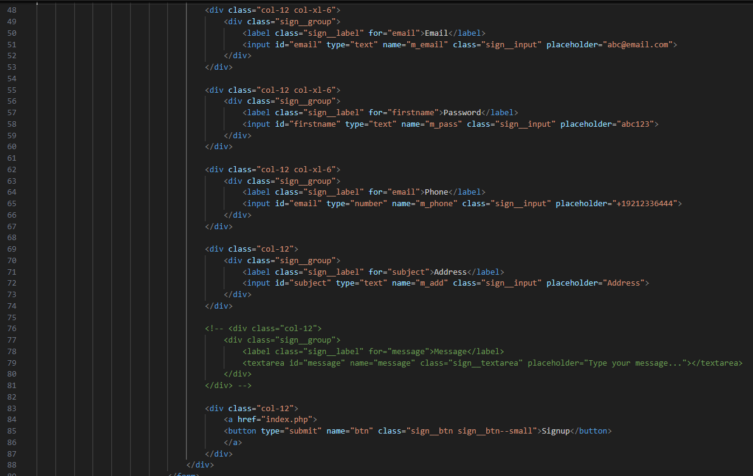

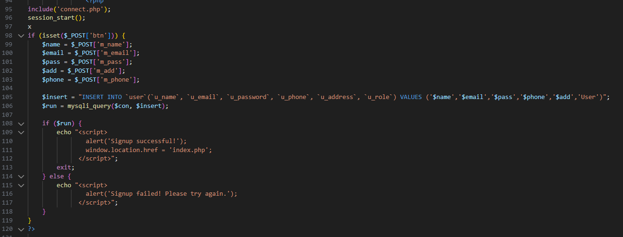

**USER / ADMIN SIGNIN PAGE**

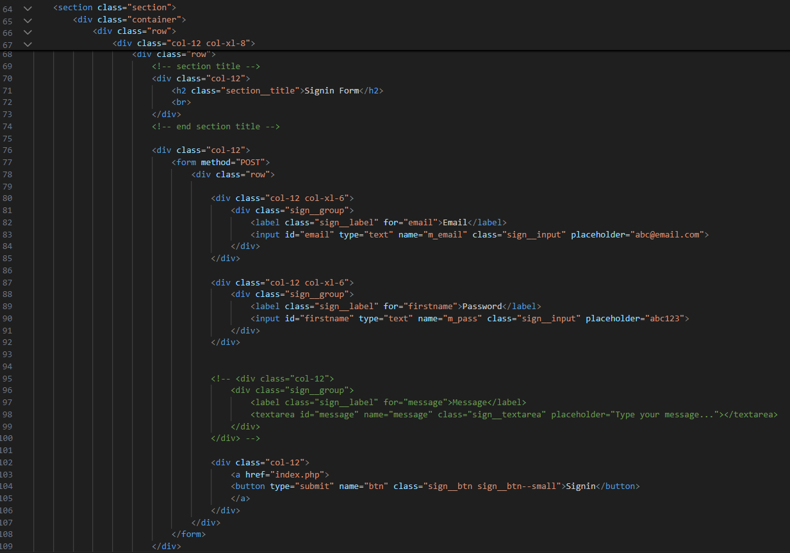

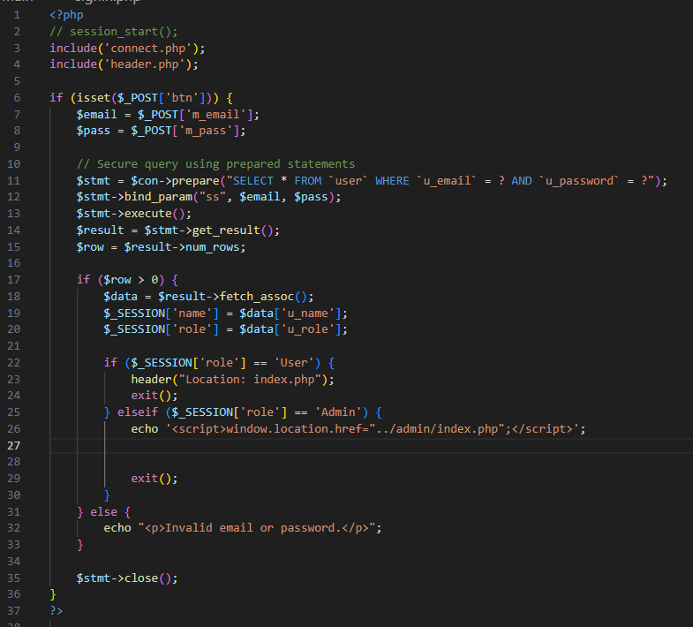

**LOGOUT**

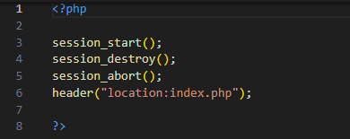

**ADD MOVIES**

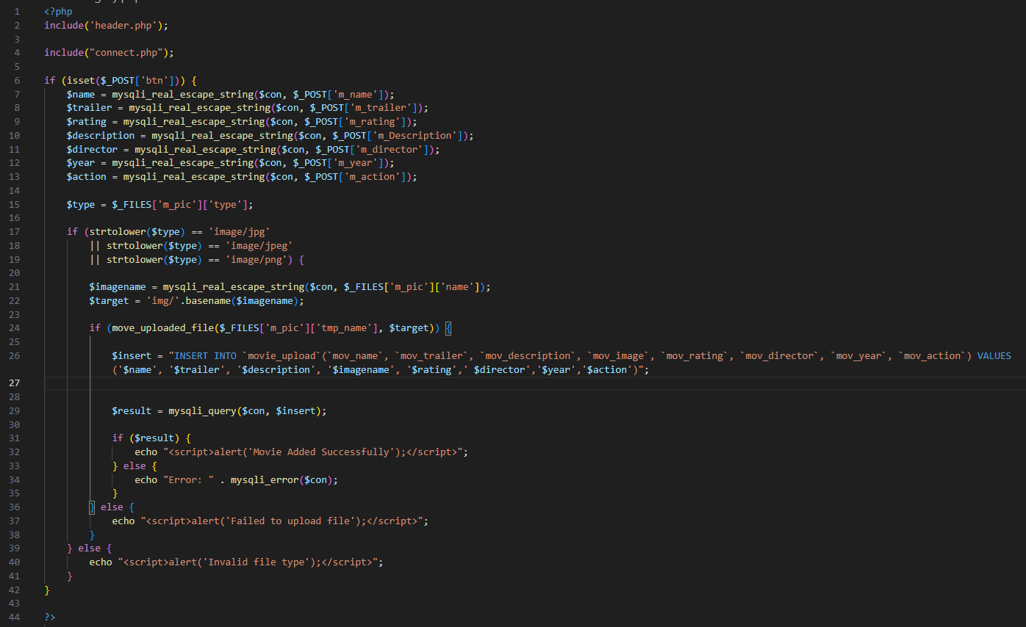

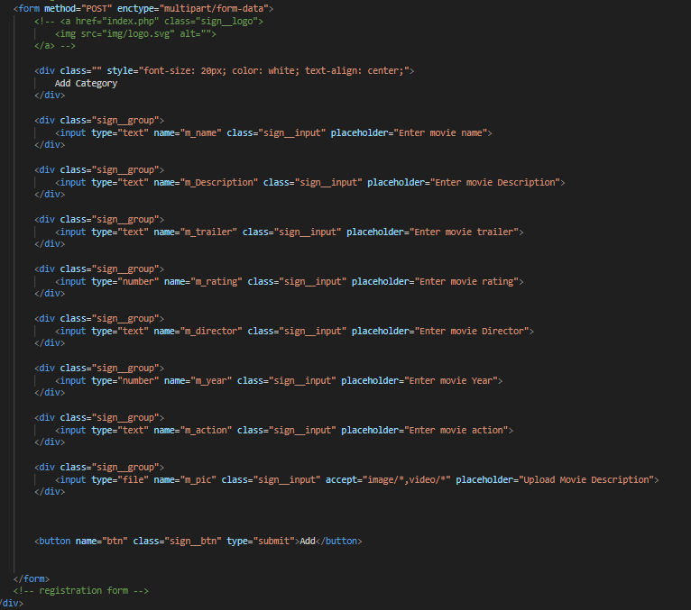

**MOVIE DETAILS**

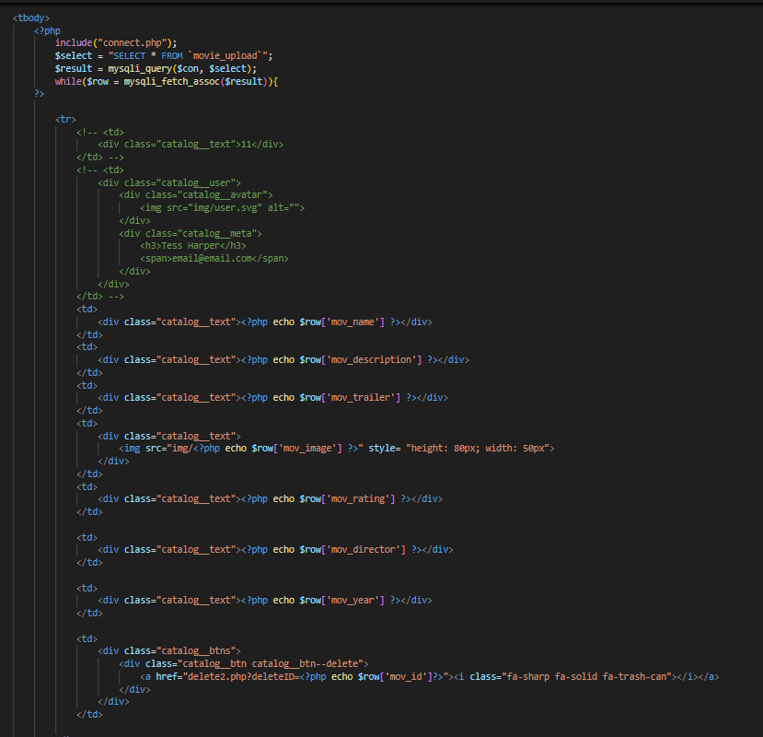

**ADD CINEMA**

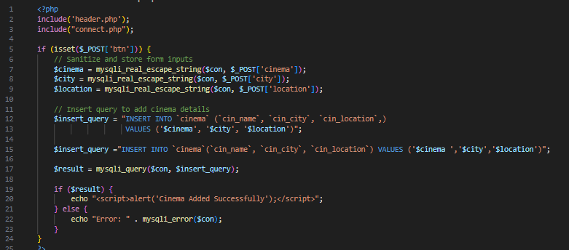

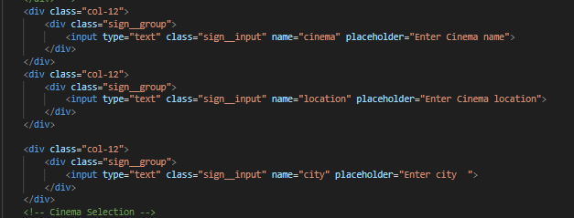

**VIEW CINEMA**

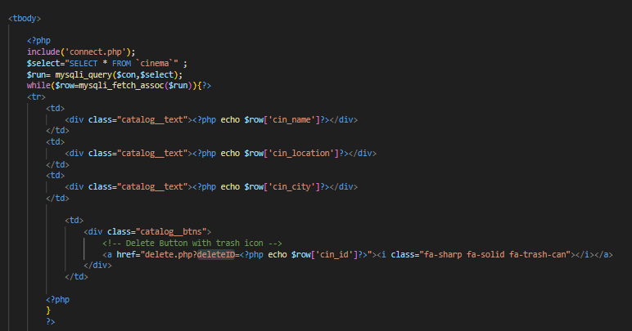

**ITEM DELETE**

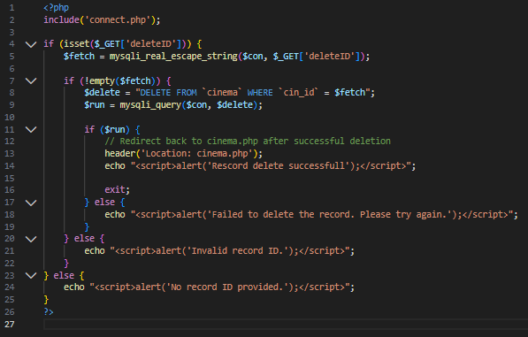

**BOOK TICKET AND TICKET PRINTING**

